DBT_pdf

Lecture 12: Introduction to NoSQL Databases and MongoDB

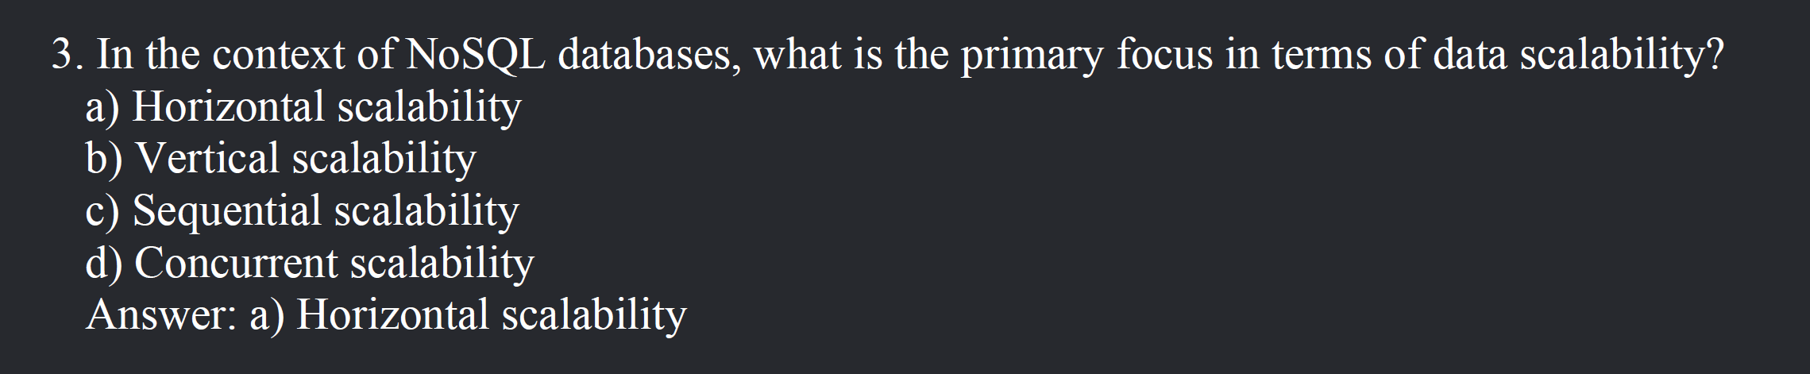

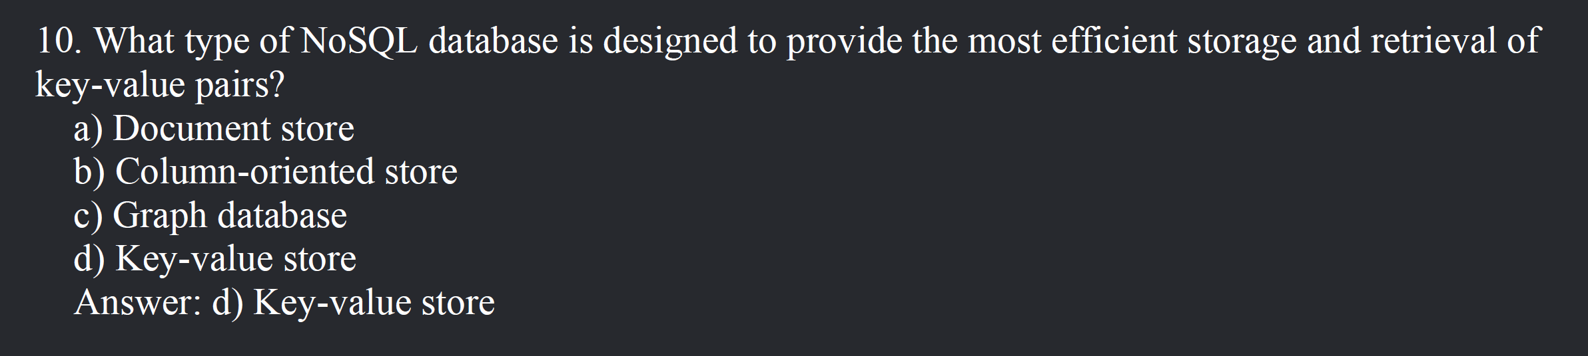

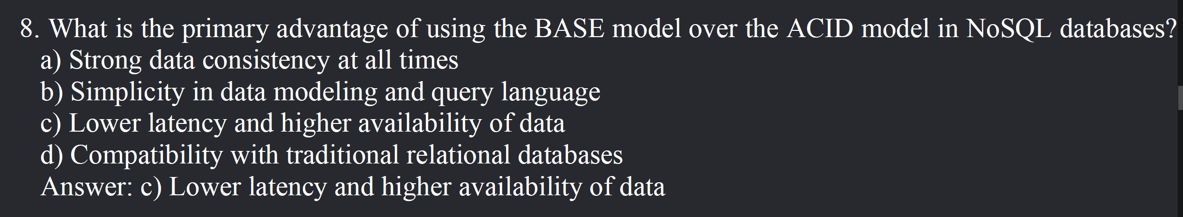

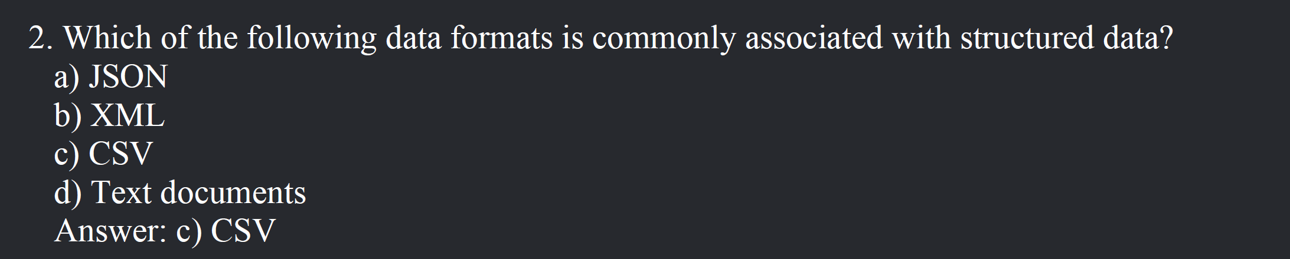

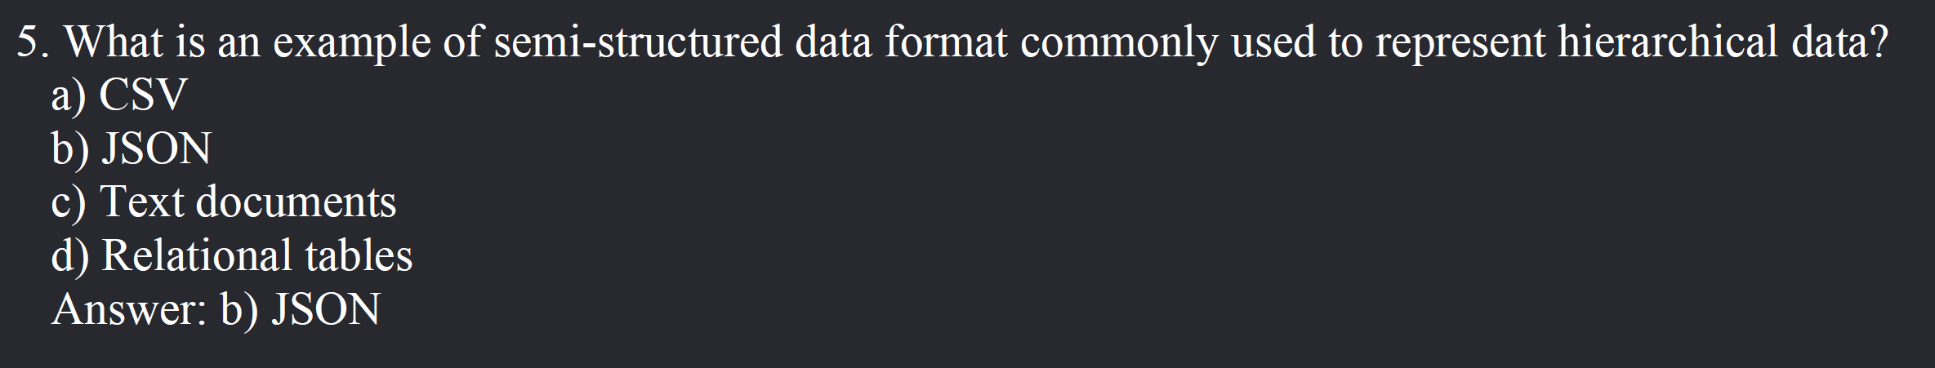

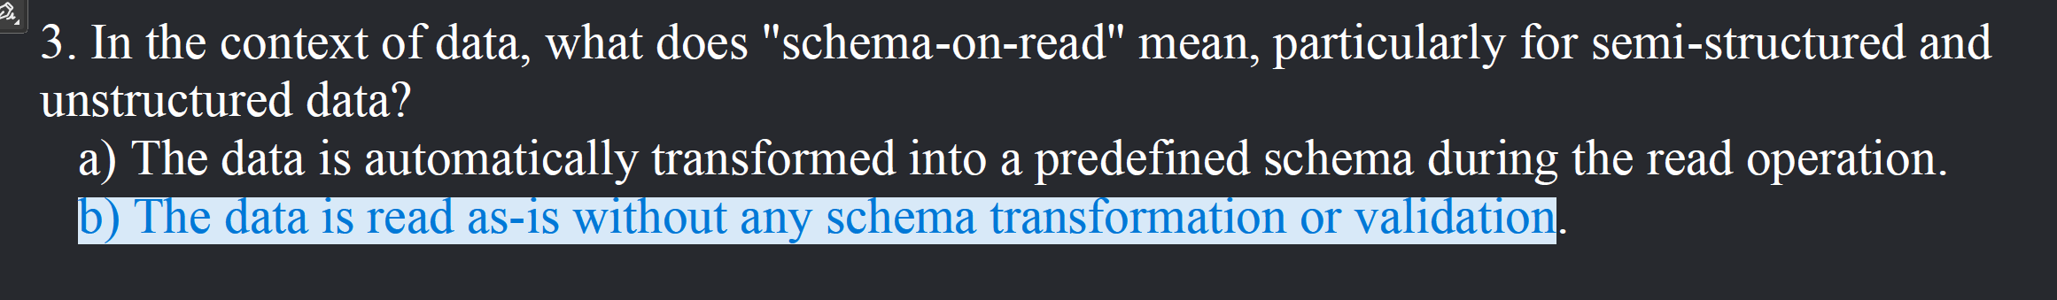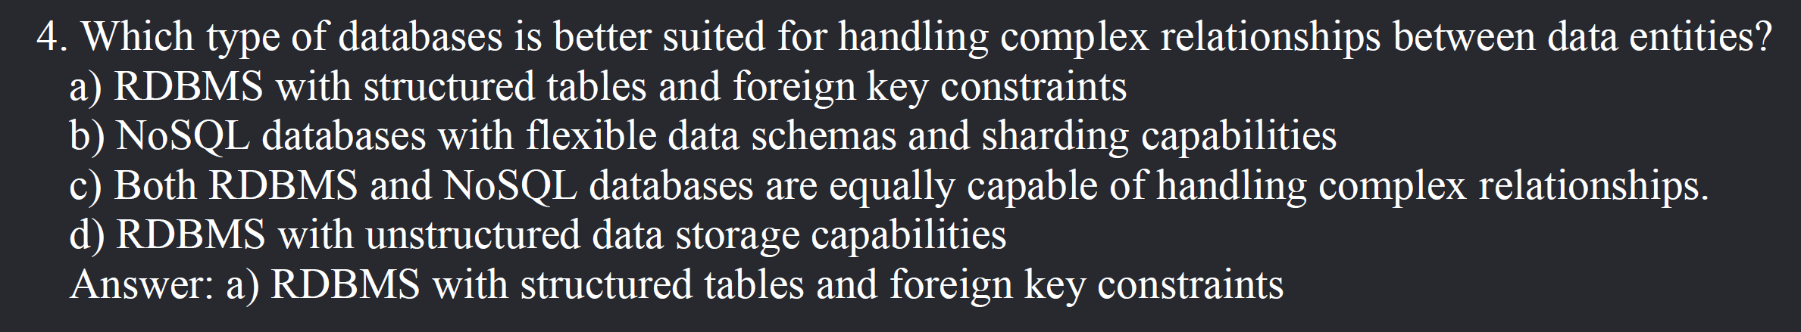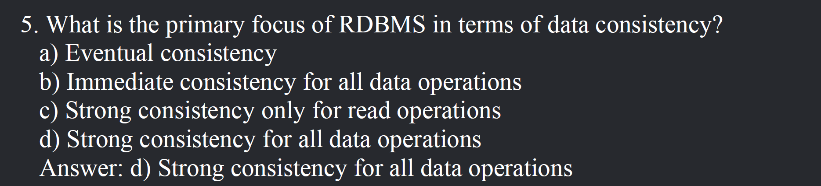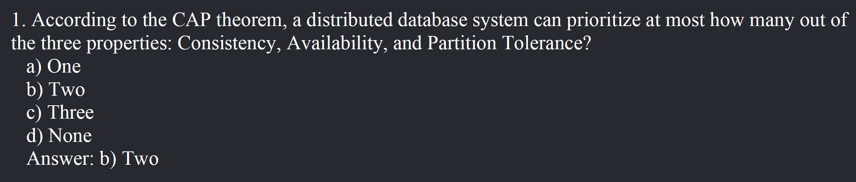

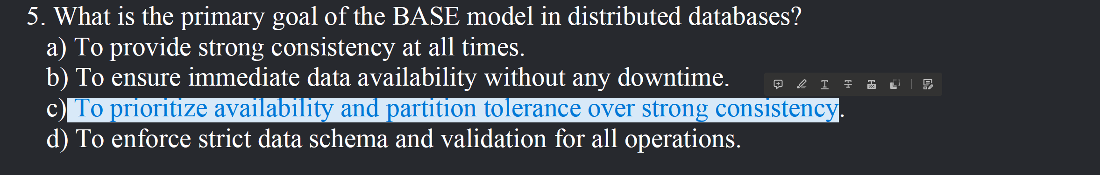

Start from here below

**12.6 Categories of NoSQL Databases: Key-Value Store, Document Store, Column-Oriented,

Graph**